 | Testing and Training Center of Farm Machinery  Department of Farm Machinery and Power Engineering  College of Agricultural Engineering and Technology  Junagadh Agricultural University  JUNAGADH – 362 001 (GUJARAT) | 
P | Phone : (0285) 2672080-90, Ext. 390 & 484; Fax : (0285) 2671018

SPECIFICATION SHEET OF M.B. PLOUGH

1.0 | General
 | Name of the implement
 | Address of Manufacturer
 | Name & Address of Applicant
 | Selling price in India
2.0 | Technical Specifications
 | Type of implement
 | Make
 | Model
 | Serial Number
 | Size of plough (mm)
 | Year of manufacture
 | Recommended prime-mover
3.0 | Constructional Details
3.1 | Main frame
 | Type of material
 | Length
 | Width at front & rear
 | Method of fixing standard
3.2 | Standard
 | Material
 | Projected length
 | Width at top/middle/bottom (mm)
 | Thickness at top/middle/bottom
 | No., size & spacing of holes for fixing frog
 | No., & size of holes for fixing to frame
 | Method of fixing
3.3 | Plough bottom
 | Type
 | Material of construction
 | Size of plough
 | Size (Length x width x Thickness) (mm)
 | Vertical suction
 | Horizontal suction
3.4 | Mould Board
 | Type
 | Material
 | Size (Length x width x Thickness)
 | Angle of inclination of mould board along the direction of travel
 | No. & size of hole on mould board
 | Method of fixing
3.5 | Share
 | Type
 | Material
 | Size (thickness)
 | No. & size of holes on share
 | Method of fixing share to the bottom
3.6 | Share nose
 | Type
 | Size (mm)
 | Angle of penetration (deg)
3.7 | Share Bar
 | Type
 | Material
 | Size (mm)
3.8 | Landside
 | Type
 | Material
 | Size (thickness)
 | No. & size of holes on landside
 | Method of fixing landside to frog
3.9 | Braces
 | Numbers
 | Material & Size
 | No. & size of holes for each brace
 | Method of fixing
3.10 | Frog
 | Type
 | Material & Size
 | No. & size of holes on frog
4.0 | Reverse mechanism
 | Type
 | Construction
4.1 | Reversing lever
 | Number
 | Material
 | Diameter & Projected curved length
 | Method of fixing
4.2 | Reverse lever holder
 | Number
 | Material & Size
 | Dia. of reverse lever holder pin hole
 | Dia. of reverse lever holder hole
 | Method of fixing reverse lever holder
4.3 | Reverse lever lock pin pipe
 | Constructional details
 | Material & Size
4.4 | Reverse lever lock pin
 | Material & Size
4.5 | Reverse lever pin spring
 | No. of spring
 | Length & diameter
 | No. of coils
4.6 | Main shaft
 | Constructional details
 | Method of fixing
5.0 | Three point linkage
 | Constructional details

Sr. | Dimension | Description (Refer Fig.) | Dimension in mm
Upper Hitch attachments
1 | d₁ | Diameter of hitch pin hole
2 | b’₁ | Width between inner faces of yoke
3 | b’₂ | Width between outer faces of yoke
Lower hitch points
4 | D₂ | Dia of hitch pin
5 | b’₃ | Linch pin hole distance
6 | l | Lower hitch point span
Other dimensions
 | Diameter of linch pin hole
7 | d | For upper hitch pin
8 |  | For lower hitch pin
9 | h | Mast height
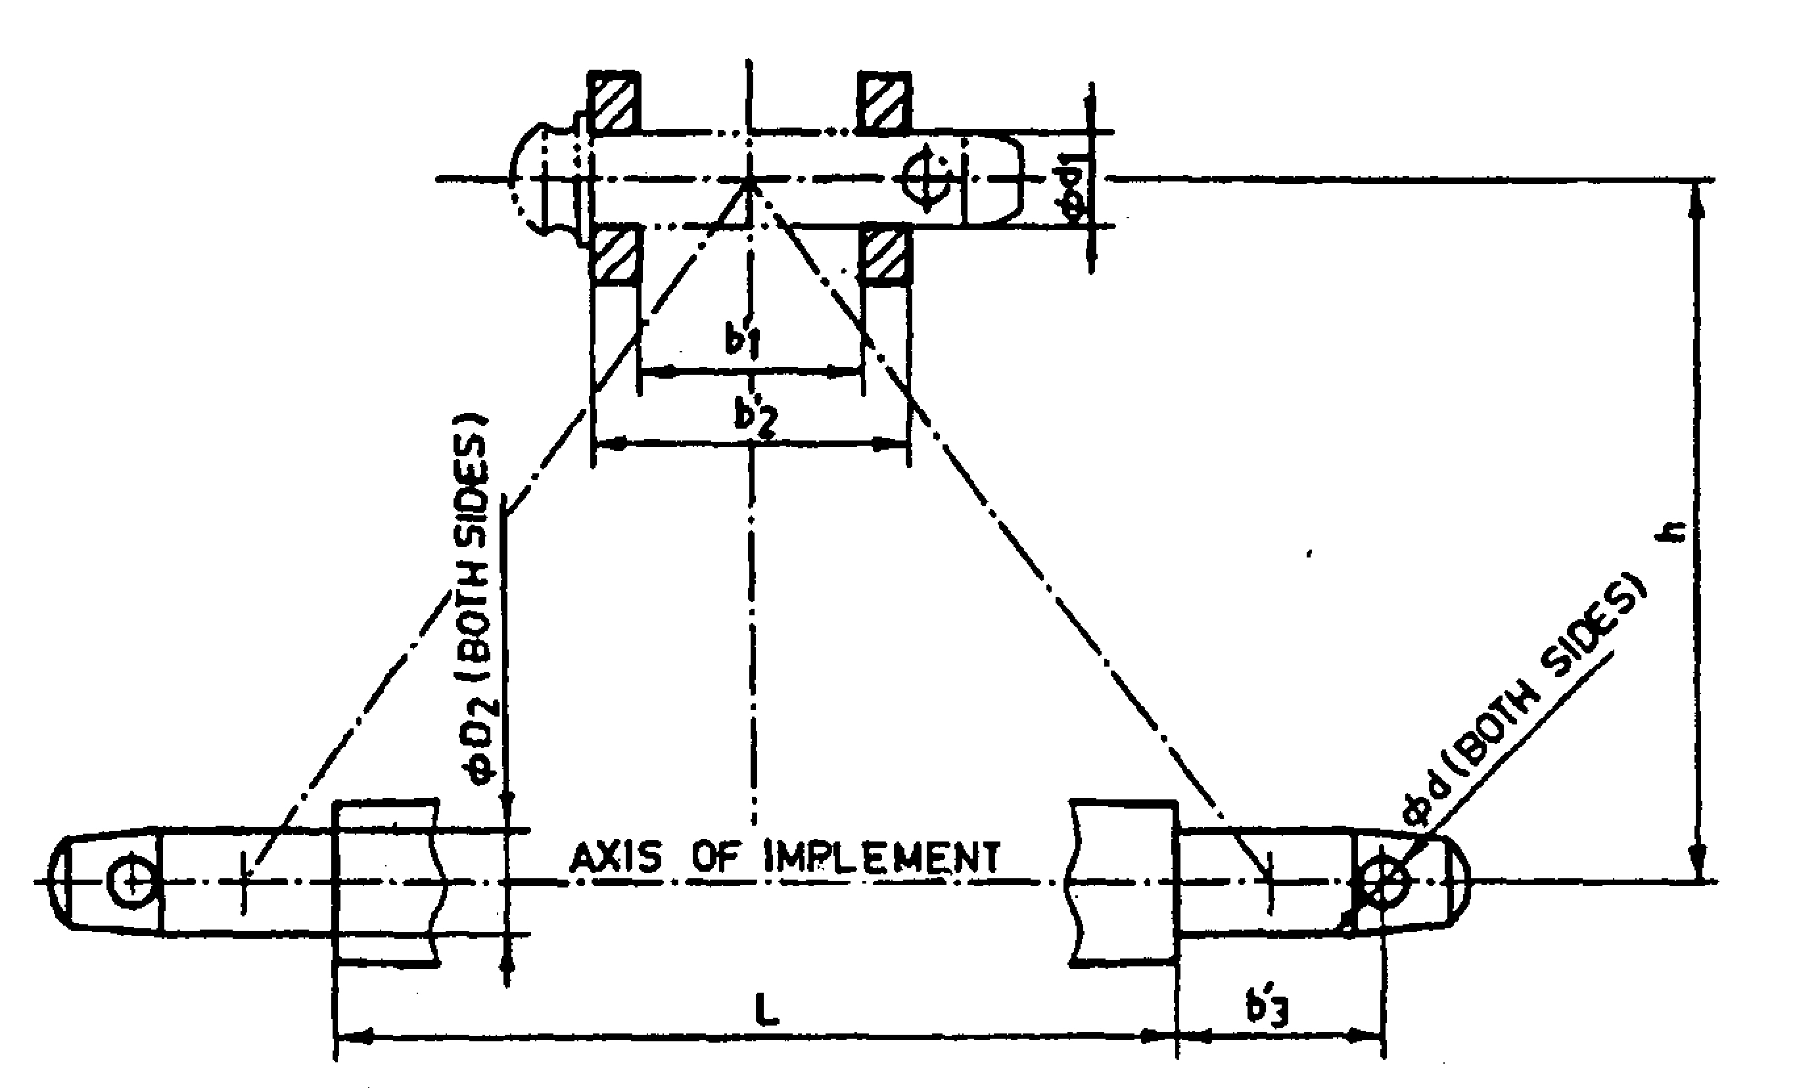
Fig. : Implement Hitch Attachment

6.0 | Overall dimensions (mm)
 | Length x Width x Height
7.0 | Mass of implement (kg)
8.0 | Colour
9.0 | Other specific details, if any

Place:
Date:
Signature : ________________________

Name : ________________________

Designation: ________________________

